HIGH-TICKET SALES FUNNEL BLUEPRINT
____

Introduction
A well-designed sales funnel is the cornerstone of successful high-ticket affiliate marketing. With potential commissions of $200 or more per sale, your funnel must be strategically crafted to nurture prospects through a careful decision journey while building the trust necessary for premium purchases. This complete guide will walk you through creating and optimizing a high-converting sales funnel specifically designed for high-ticket products.
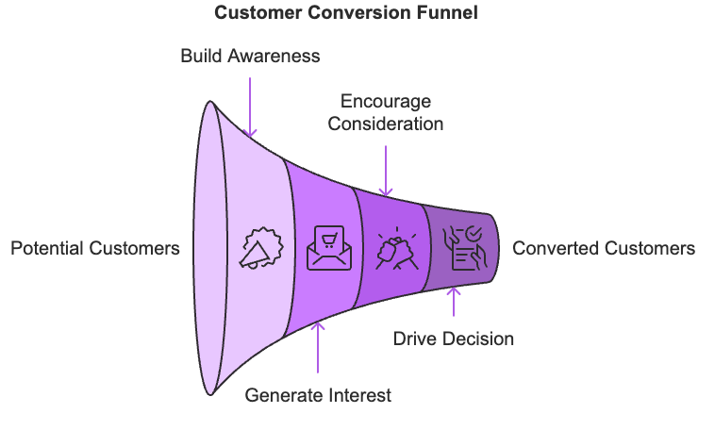

Foundation Planning

Understanding Your Target Audience
Before building your funnel, you need to clearly define who you're targeting:
Buyer Persona Development:
- Document demographic information
- Identify primary pain points and challenges
- List key motivators for purchasing premium solutions
- Map out typical objections and concerns
- Understand their decision-making process
Exercise: Create a detailed buyer persona profile including all above elements

Mapping the Customer Journey
Your high-ticket funnel should align with how premium buyers make decisions:
- Awareness Stage
- Initial problem recognition
- Beginning research phase
- Seeking educational content
- Consideration Stage
- Evaluating potential solutions
- Comparing options
- Looking for social proof

- Decision Stage
- Seeking validation
- Requiring personal attention
- Ready for detailed information
Action Item: Create a journey map documenting touchpoints at each stage

Lead Magnet Development

Creating Premium Lead Magnets
Your lead magnet must offer substantial value while qualifying prospects:
Effective Formats:
- Comprehensive video training series
- Detailed industry reports
- ROI calculators
- Free consultation sessions
- Expert interview collections
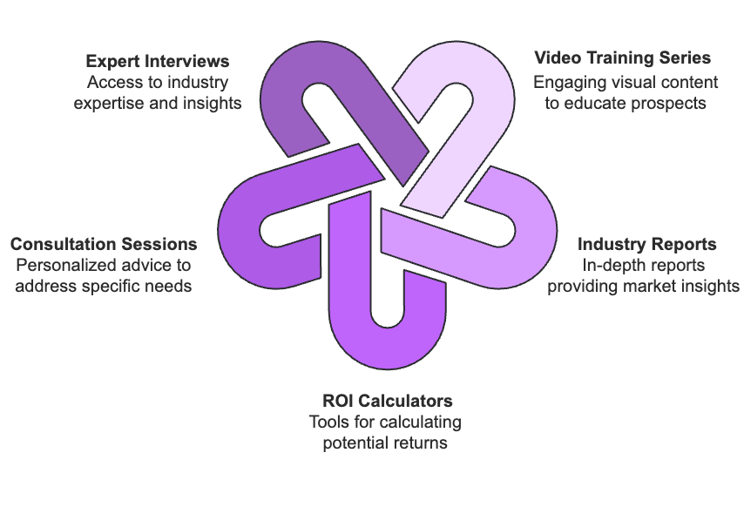
Key Elements:
- Addresses specific industry challenges
- Demonstrates your expertise
- Provides immediate value
- Sets up the need for your premium solution
- Qualifies serious buyers
Exercise: Outline 3 potential lead magnet ideas based on your audience's needs

Lead Magnet Optimization
To maximize effectiveness:
- Include clear call-to-actions
- Maintain professional design standards
- Deliver immediate results
- Build anticipation for next steps
- Track engagement metrics

Email Nurture Sequence

Welcome Sequence Design
Create a strategic welcome series:
Day 1:
- Welcome message
- Quick win delivery
- Clear next steps
- Set expectations
Day 2-3:
- Problem amplification
- Industry insights
- Social proof introduction
Day 4-7:
- Solution presentation
- Case study sharing
- Benefit demonstration

Main Nurture Sequence
Develop a comprehensive nurturing flow:
- Value Building (Weeks 1-2)
- Educational content
- Expert insights
- Industry trends
- Success stories
- Solution Presentation (Weeks 3-4)
- Product features
- Implementation examples
- ROI analysis
- Common objections addressed
- Decision Support (Weeks 5-6)
- Detailed case studies
- Comparison guides
- FAQ responses
- Social proof emphasis
Action Item: Create email templates for each sequence stage

Conversion Elements

High-Value Content Creation
Develop premium content pieces:
Core Content Types:
- In-depth product reviews
- Comprehensive solution guides
- Video demonstrations
- Expert interviews
- Implementation tutorials
Content Standards:
- Professional production quality
- Detailed analysis
- Original insights
- Actionable takeaways
- Clear value proposition

Converting Landing Pages
Design high-converting pages:
Essential Elements:
- Clear value proposition
- Social proof sections
- Trust indicators
- Professional design
- Mobile optimization
- Clear call-to-actions
Exercise: Create a landing page template incorporating all elements

Engagement Systems

Webinar Strategy
Develop engaging webinar content:
Webinar Structure:
- Value-rich opening
- Problem exploration
- Solution presentation
- Implementation guidance
- Q&A session
- Clear next steps

Community Building
Create exclusive spaces:
- Private Facebook groups
- LinkedIn communities
- Member-only forums
- Expert Q&A sessions
- Success celebration events

Optimization Framework

Key Metrics Tracking
Monitor essential metrics:
Conversion Metrics:
- Opt-in rates
- Email engagement
- Webinar attendance
- Sales conversion
- Customer lifetime value
Engagement Metrics:
- Content interaction
- Social sharing
- Community participation
- Support requests
- Referral rates

Testing Protocol
Implement systematic testing:
Weekly Tests:
- Email subject lines
- Call-to-action placement
- Landing page elements
- Content formats
- Offer presentation
Monthly Analysis:
- Conversion rates
- Traffic sources
- Content performance
- Funnel efficiency
- ROI calculation

Implementation Plan

30-Day Launch Timeline
Week 1:
- Create buyer persona
- Design lead magnet
- Develop landing page
Week 2:
- Build email sequences
- Create core content
- Set up tracking systems
Week 3:
- Launch initial funnel
- Begin traffic generation
- Monitor metrics
Week 4:
- Optimize based on data
- Scale successful elements
- Plan next improvements

Action Plan

Immediate Actions (Next 24 Hours)
- Complete buyer persona worksheet
- Choose lead magnet topic
- Draft initial email sequence outline

Week One Tasks
- Create lead magnet content
- Build landing page
- Set up email automation

Week Two Tasks
- Launch traffic generation
- Monitor metrics
- Begin optimization

Ongoing Activities
- Weekly metric review
- Monthly optimization
- Quarterly strategy assessment

Conclusion
Your high-ticket sales funnel is a sophisticated system that requires careful planning and consistent optimization. Start with the foundation elements, build systematically, and focus on delivering premium value at every stage. Remember that success in high-ticket affiliate marketing comes from building trust and demonstrating expertise throughout the buyer's journey.
Begin implementing this blueprint today by completing the immediate actions in the action plan. Track your results, optimize based on data, and continuously improve your funnel's performance. With dedication and systematic implementation, you'll build a powerful conversion system that generates significant high-ticket commissions consistently.

